|  |  |  |
| --- | --- | --- |
| **Year 7 Science** | Name: __________________ | |
| **Home reading and Homework** | Due: _______________ | |
| **WEEK ONE** | Parent /carer signature: ___________________ | |
| **Home reading:** Science Essentials 7 Chapter 1.1 and 1.2 | |
| **Homework:** Complete the activity below | |

**Laboratory Equipment**

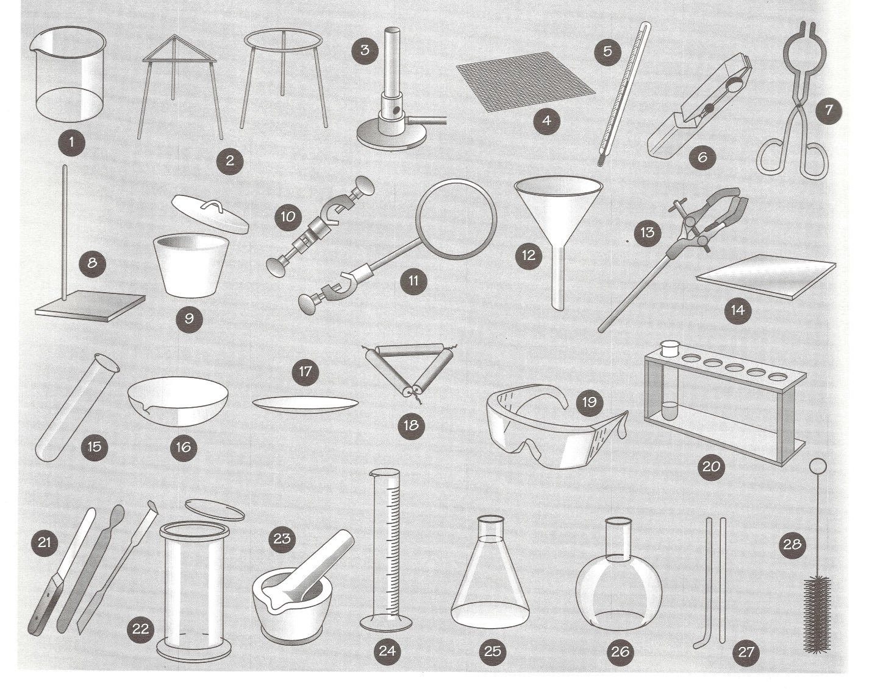

Write the number next to its correct label. The first one is done for you.

|  |  |  |  |  |  |
| --- | --- | --- | --- | --- | --- |
| *Evaporating basin* |  | *Beaker* | ***1*** | *Test tube* |  |
| *Retort stand* |  | *Conical flask* |  | *Spatulas* |  |
| *Measuring cylinder* |  | *Tripod stands* |  | *Clamp* |  |
| *Gas jar and lid* |  | *Stirring rod* |  | *Test tube rack* |  |
| *Crucible tongs* |  | *Boss head* |  | *Watchglass* |  |
| *Ring clamp* |  | *Round bottom flask* |  | *Pestle and mortar* |  |
| *Test tube holder* |  | *Crucible and lid* |  | *Safety glasses* |  |
| *Pipe-clay triangle* |  | *Test tube brush* |  | *Filter funnel* |  |
| *Bunsen burner* |  | *Heat mat* |  |  |  |
| *Gauze mat* |  | *Thermometer* |  |  |  |